Making a Capacitive sensor with electric paint to keep the
How to make the Capacitive sensor with electric paint：
https://youtu.be/Nj31qloMX54
Materials：
1 x Electric Paint 50ml
-
Paintbrush
Paper
Arduino
USB Cable
Bread Board
Jump Wires
Resistors
Aligator Clip
Paper Clip
Continue the project “Mid-term”
(Control a DC motor)

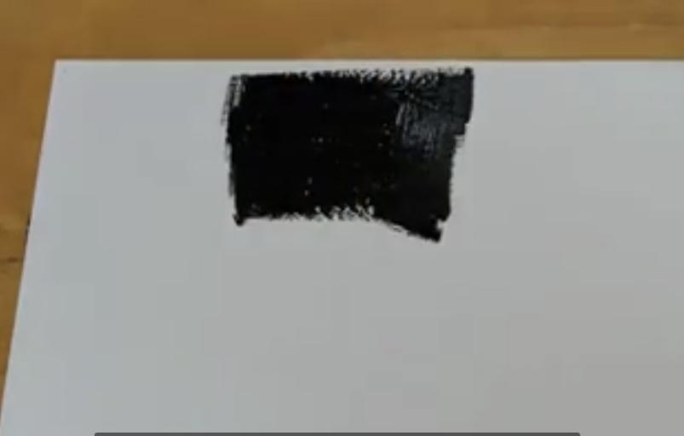
OR
Paper piano
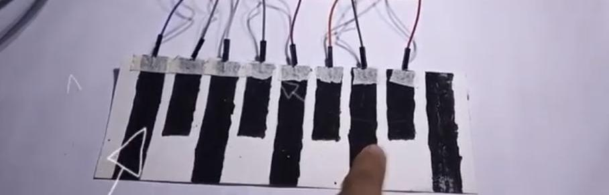
https://youtu.be/sqQzIN7G6Oc

CODE:

#include <CapacitiveSensor.h>
#define buzzer 11
// Set the Send Pin & Receive Pin.
CapacitiveSensor cs_12_3 = CapacitiveSensor(12,3);
CapacitiveSensor cs_12_4 = CapacitiveSensor(12,4);
CapacitiveSensor cs_12_5 = CapacitiveSensor(12,5);
CapacitiveSensor cs_12_6 = CapacitiveSensor(12,6);
CapacitiveSensor cs_12_7 = CapacitiveSensor(12,7);
CapacitiveSensor cs_12_8 = CapacitiveSensor(12,8);
CapacitiveSensor cs_12_9 = CapacitiveSensor(12,9);
CapacitiveSensor cs_12_10 = CapacitiveSensor(12,10);
void setup()
{
// turn off autocalibrate on channel 1 - just as an example
cs_12_3.set_CS_AutocaL_Millis(0xFFFFFFFF);
cs_12_4.set_CS_AutocaL_Millis(0xFFFFFFFF);
cs_12_5.set_CS_AutocaL_Millis(0xFFFFFFFF);
cs_12_6.set_CS_AutocaL_Millis(0xFFFFFFFF);
cs_12_7.set_CS_AutocaL_Millis(0xFFFFFFFF);
cs_12_8.set_CS_AutocaL_Millis(0xFFFFFFFF);
cs_12_9.set_CS_AutocaL_Millis(0xFFFFFFFF);
cs_12_10.set_CS_AutocaL_Millis(0xFFFFFFFF);
}
void loop()
{
// Set the sensitivity of the sensors.
long touch1 = cs_12_3.capacitiveSensor(1000);
long touch2 = cs_12_4.capacitiveSensor(1000);
long touch3 = cs_12_5.capacitiveSensor(1000);
long touch4 = cs_12_6.capacitiveSensor(1000);
long touch5 = cs_12_7.capacitiveSensor(1000);
long touch6 = cs_12_8.capacitiveSensor(1000);
long touch7 = cs_12_9.capacitiveSensor(1000);
long touch8 = cs_12_10.capacitiveSensor(1000);
// When we touched the sensor, the buzzer will produce a tone.
if (touch1 > 1000){
tone(buzzer,400);
}
if (touch2 > 1000){
tone(buzzer,270);
}
if (touch3 > 1000){
tone(buzzer,650);
}
if (touch4 > 1000) {
tone(buzzer,900);
}
if (touch5 > 1000){
tone(buzzer,1100);
}
if (touch6 > 1000){
tone(buzzer,1300);
}
if (touch7 > 1000){
tone(buzzer,1670);
}
if (touch8 > 1000){
tone(buzzer,2000);
}
// When we didn't touch it, no tone is produced.
if (touch1<=1000 & touch2<=1000 & touch3<=1000 & touch4<=1000 & touch5<=1000 & touch6<=1000 & touch7<=1000 & touch8<=1000)
noTone(buzzer);
delay(10);
